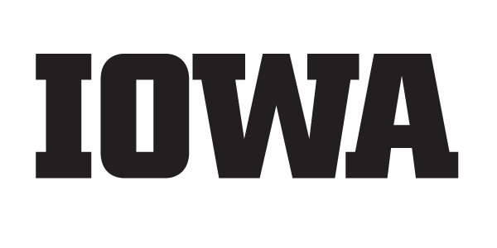
University of Iowa
State Fair Booth
August 10-20, 2023
Volunteer Information

- Attire – You will be provided a black University of Iowa t-shirt when you arrive. Please plan to wear it with black or tan shorts, skirt or slacks, and comfortable shoes (you will be standing in most volunteer positions). Keep in mind that you are representing the UI. The Varied Industries Building is air conditioned, but it can be hot getting to and from the building.

- Parking/Shuttles – Parking is in the North lot of the fairgrounds by using the ticket we send to you. Please be aware lots are likely to fill up by late morning or early afternoon on weekends or during high-attendance events. An alternative is to take a shuttle from Southeast Polk High School, Center Street or the State Capitol, and other locations in Des Moines. See https://www.iowastatefair.org/visit/parking-dart-park-ride for more information.

- Booth Location – The UI booth is in the Varied Industries Building, on Grand Ave. across from the Grandstand. The UI exhibit is located in the southwest corner of the building. A fair map can be found at https://statefair.sites.uiowa.edu/volunteers

- Check-In – Please arrive a few minutes before your shift begins to allow for a shift change and check in with a booth lead. You will receive a t-shirt and nametag and we will find an area where you can help. There will be a place in our storage area for small bags and purses. Please do not bring large items with you.

- What you will be doing – Volunteers will be handing out football posters, reusable bags, pencils, buttons, and temporary tattoos; assisting in booth traffic around the trophies and interacting with Herky and the Iowa Spirit Squad, and answering questions from fair attendees.

Guidelines for workers –
- You are representing the University of Iowa and you may be the first contact for a potential student, donor, or ticket buyer. First impressions are important!
- Be polite, patient, and professional while keeping an energetic and upbeat attitude.
- Use your “people skills” and always be willing to help fairgoers and other volunteers.
- Be positive about the University of Iowa, all of its programs, and everything else that goes along with being a Hawkeye. Please do not negatively comment about other schools.
- Be knowledgeable about the University. Please read the University of Iowa Highlights on our State Fair website linked below. If you don't know the answer, ask the booth staff or Admissions Counselor. Those seeking more information can also fill out an information request card.
- Please refrain from using your cell phone or texting during your shift.
- You can take a short break (bathroom, drink, etc.), but don't leave your area unattended. Please, no food while working in the booth; water and beverages are fine. We will provide bottled water for volunteers.
- And most importantly, have fun and Go Hawks!

Please visit the State Fair website, https://statefair.sites.uiowa.edu/volunteers for more information about the booth.

